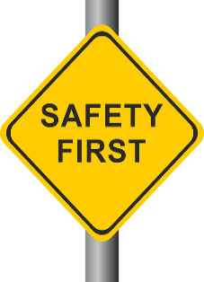
SAFETY TIPS
Let’s be safe while making a difference in our community!

- Wear gloves and thick-soled, closed shoes
- Wear long pants and long-sleeved shirts
- Wear safety vests or bright colors for roadside cleanups
- Wear sunscreen and bug repellent
- Drink plenty of fluids and keep “quick energy foods” on hand
- Be aware of your surroundings and the potential hazards associated with them (e.g. passing cars, hazardous tree branches, poison ivy, etc.)
- Use the “buddy system” and work in teams of two or three to maximize safety
- Wash hands with soap after the cleanup
- Bag litter according to directions and place in designed locations
- Don’t pick up hazardous materials such as hypodermic needles, sharp objects, old car batteries, animal carcasses or other unidentified, questionable objects
- Don’t overstuff bags
- Don’t bring pets to events, as they may distract participants or even detract from the cleanup
- Don’t attempt to move large, heavy objects. Report illegal dumping, graffiti, tires and bulky items to the event coordinators
- Remember to take breaks when needed.

